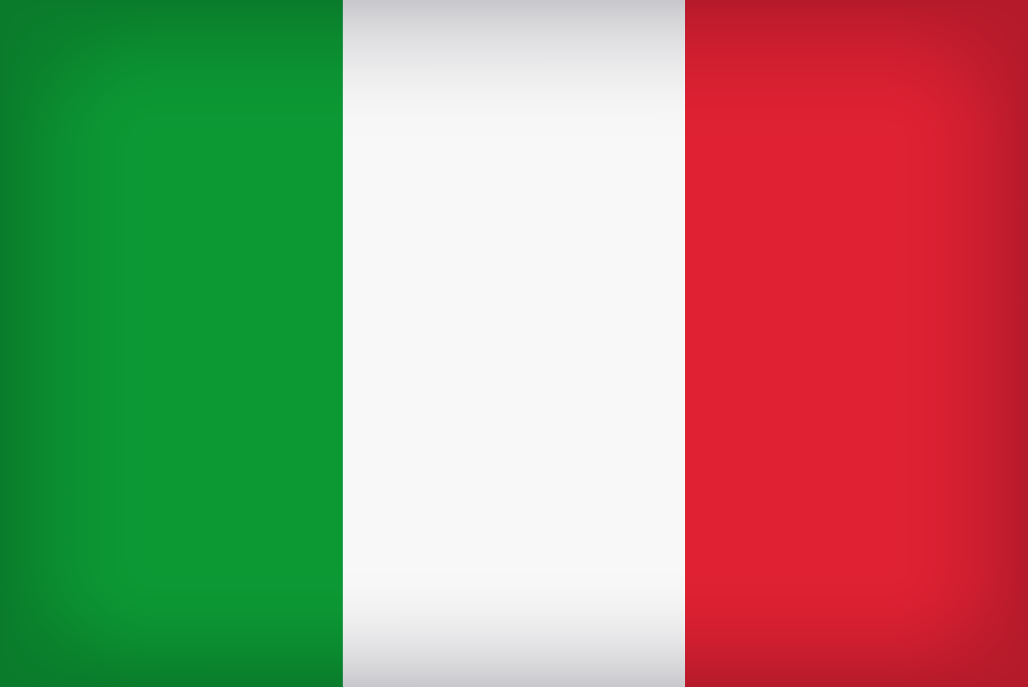
Italy to Madison:
How Arts Shape Culture and Culture Shapes the World
GS 340/341 COR 2G
Spring 2022, travel June 2022

This interdisciplinary and experiential course consists of two parts: the first conducted in weekly class meetings during the spring semester, and the second in Rome and Urbino, Italy, during early June. The Madison part of the course will offer an integrative introduction to the arts, culture, and social issues of Italy — from the ancient Romans, to the Renaissance, to the present. Our goal will be to analyze and study how inherently linked the arts and their shared histories are to one another, and to understand how they have always been connected with broader issues of humanity, from ancient times to our contemporary world.

Information sessions:
      - Thursday, September 27, 3:00-4:00 PM
      - Friday, October 5, 12:00-1:00 PM
Both sessions will be held in the second-floor Library conference room.

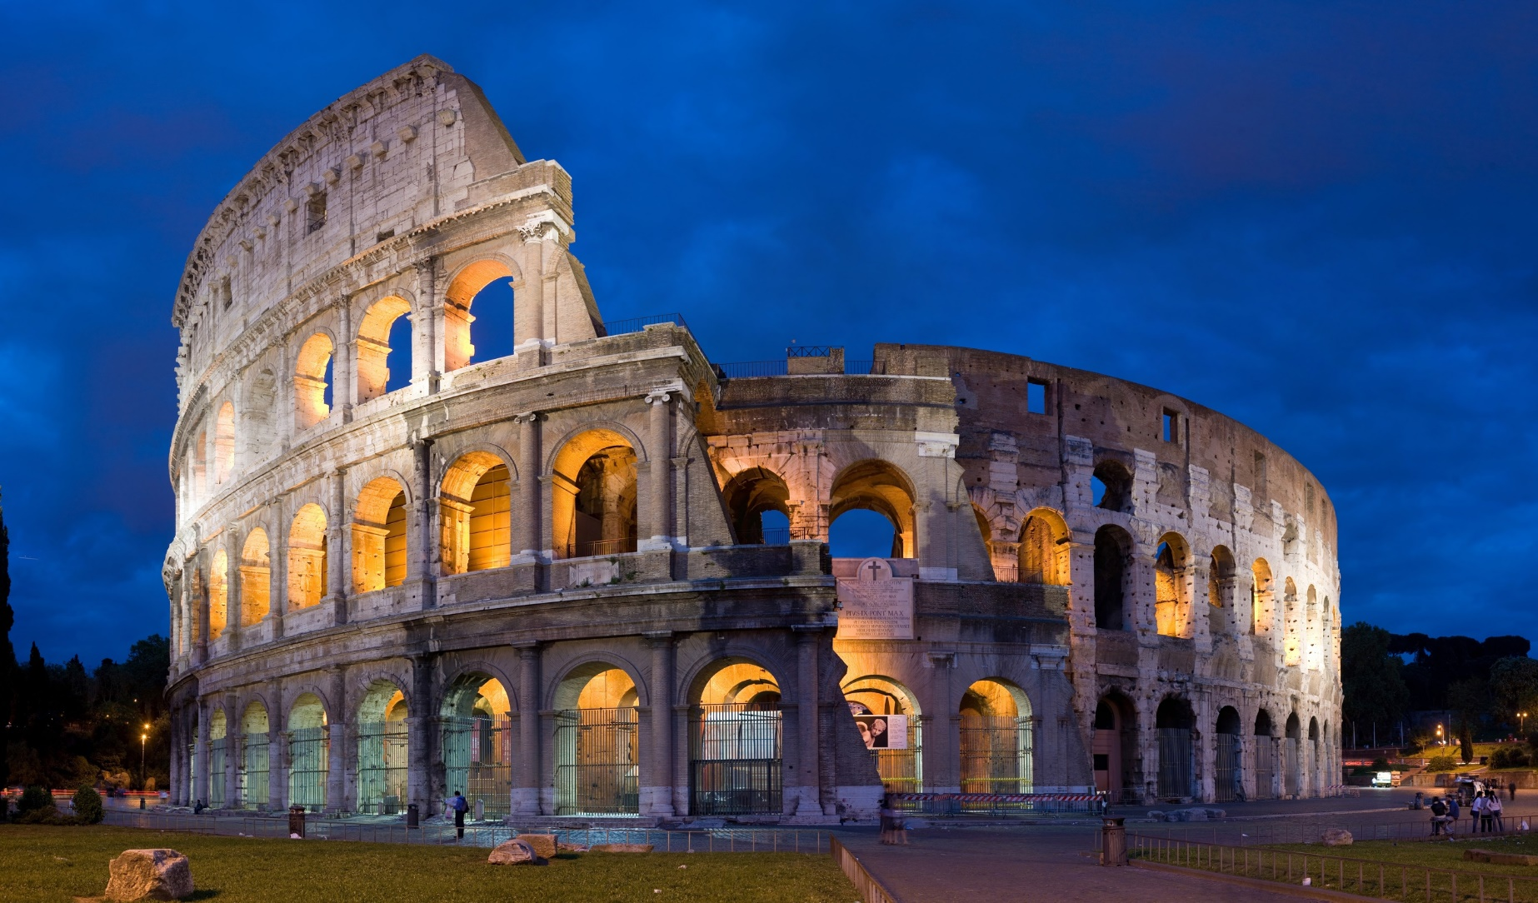
Program & scholarship applications are only available online!

Go to globaleducation.edgewood.edu to get started,
or stop by the Center for Global Education in Predolin 340 for more information.

